Sustainability and Preparedness Plan for Transition from International to Domestic Financing of TB Control Activities

Almaty, 2018

TUBERCULOSIS CONTROL PROGRAM IN THE REPUBLIC OF KAZAKHSTAN

APPROVED

Director of the National Scientific Center of Phthisiopulmonology

of the Ministry of Health of the Republic of Kazakhstan,

the Republican State Enterprise on the Right of Economic Use

M.M. Adenov

dated __________ ___, 2018

SUSTAINABILITY AND PREPAREDNESS PLAN FOR TRANSITION FROM INTERNATIONAL TO DOMESTIC FINANCING OF TB CONTROL ACTIVITIES

Almaty, 2018

Table of content

INTRODUCTION 4
COUNTRY CONTEXT 5
INTERNAL ENVIRONMENT 10
FINANCIAL TB CONTROL RESOURCES 12
HUMAN RESOURCES 15
TRANSITION PLANNING 18

INTRODUCTION

The Global Fund has been providing support to the National Tuberculosis Program in Kazakhstan since 2007. By October 31, 2018, the amount of $79.17 mln had been invested. The current grant amounts to $17.64 mln for a period of three years (till December 2019). It provides support to achieve the goal of the Comprehensive Plan for TB control in the Republic of Kazakhstan for the years 2014-2020 to reduce the tuberculosis burden in the country by reforming the disease control system and strengthening the management of drug-resistant tuberculosis (DR-TB) by ensuring universal access to diagnosis and treatment of drug-resistant tuberculosis (DR-TB) and meeting the needs of at-risk groups such as inmates, people living with HIV and labor migrants.

The Global Fund provides financial support to achieve the following main objectives:
(a) Support of reforming the anti-tuberculosis service by strengthening the management of the National Tuberculosis Program, monitoring and evaluation, and capacity building; (b) improving the timely detection and quality of diagnosis of TB and DR-TB cases; (c) promoting high-quality and evidence-based treatment of DR-TB cases; (d) enhancing the collaboration and response to control TB/HIV co-infection; (e) strengthening of TB and DR-TB control in the penitentiary system; (f) enhancement of partnership with the civilian sector for efficient control over TB, DR-TB and TB/HIV; (g) development and implementation of highly efficient control activities over TB, M/XDR-TB and TB/HIV for internal and external migrants.

In accordance with sub-clause 5.6 of the Grant Agreement signed between the Republic of Kazakhstan and the Global Fund to Control AIDS, Tuberculosis and Malaria, on November 28, 2016, “Not later than December 31, 2018, the Beneficiary acting through the Principal Recipient, in cooperation with the Country Coordinating Mechanism of Kazakhstan (CCM), other stakeholders and partners in the Republic of Kazakhstan, will prepare and submit to the Global Fund the Transition Plan of the National Tuberculosis Control Program in form and content satisfactory to the Global Fund”.
The main objective of this Plan is to ensure a smooth transition from the Global Fund’s support to domestic financing of TB control activities in the country. On April 12, 2018, the Country Coordinating Mechanism of Kazakhstan issued a resolution to determine the steps and composition of the working group on the development of a transition and sustainable development plan for transition phase.
Today, the main point is the fact that the government has already taken significant steps to provide funding for the key program activities. This fact is reflected in the approved Comprehensive Plan for TB Control in the Republic of Kazakhstan for the years 2014-2020, which includes transition commitments to a considerable extent, and during recent years this Plan was funded more than 90% from national sources.

BASIC DEFINITIONS
Transition is defined as “a mechanism for a country or a component-country to go towards full funding and implementation of its health care programs, regardless of support from the Global Fund, while continuing to maintain and increase its profit as much as possible”.
Sustainability means the ability of a health care program or a country to maintain and expand a service area to a level (depending on the epidemiological situation) that will provide ongoing control over the public healthcare problem and support efforts to eradicate the three diseases even after the exclusion of external funding from the Global Fund and other major external donors”.
An analysis of possible risks inherent in the transition to full funding of TB control activities in Kazakhstan from national sources is presented below.
COUNTRY CONTEXT
The Republic of Kazakhstan is located in Central Asia. It is the ninth largest country in the world by land area (2,724,900 sq.km). At the beginning of 2018, the country population was 18,157,377 inhabitants, including urban population 10,423,569 (57.4%) and rural population 7,733,768 (42.6%). The total population density is 6.7 people per 1 sq.km. The administrative division of the country at the first level includes 17 units: 14 regions and 3 cities of republican significance – Astana, Almaty and Shymkent . The second level of administrative division includes 160 rural districts, 16 urban districts and 37 cities of regional significance. Kazakhstan is ranked by the World Bank as an upper-middle income (UMI) country; Gross National Income (GNI) per capita in 2017 was estimated at the level of USD 7,890.
Tuberculosis (TB) re-emerged as an important public healthcare problem in the 1990s, and its burden remains high in Kazakhstan. According to the latest WHO estimates, TB incidence rate (new cases and relapses) is 66 per 100,000, which is the 9th highest level among 53 countries of the WHO European Region. At the same time, the estimated TB mortality in 2017 was relatively low (0.89 cases per 100,000 excluding TB/HIV and 0.20/100,000 from HIV-associated TB). It should be noted that over the last decade the WHO has significantly decreased the estimated TB incidence in Kazakhstan (from over 150 cases per 100,000 in 2008-2009 to 66/100,000 in 2017); since 2004, the estimated incidence rate in Kazakhstan has decreased by an average of 7.5% per year.
As shown in Figures 1 and 2 below, over the last ten years the annual number of notified cases of TB decreased more than twice in Kazakhstan; the case notification rate per 100,000 decreased for new case from 125.6 to 52.2 (by 58.4%), and for all TB cases – from 184.5 to 79.1 (by 57.1%).
The active group of TB patients decreased 2 times from 31,779 in 2008 to 16,261 in 2017, and the incidence rate among children also decreased 2 times from 26.0 in 2008 to 13.3 in 2017.
Figure 1 TB case notification rates in Kazakhstan per 100,000 population, 2008-2017. | Figure 2 Annual number of notified TB cases in Kazakhstan, 2008-2017.
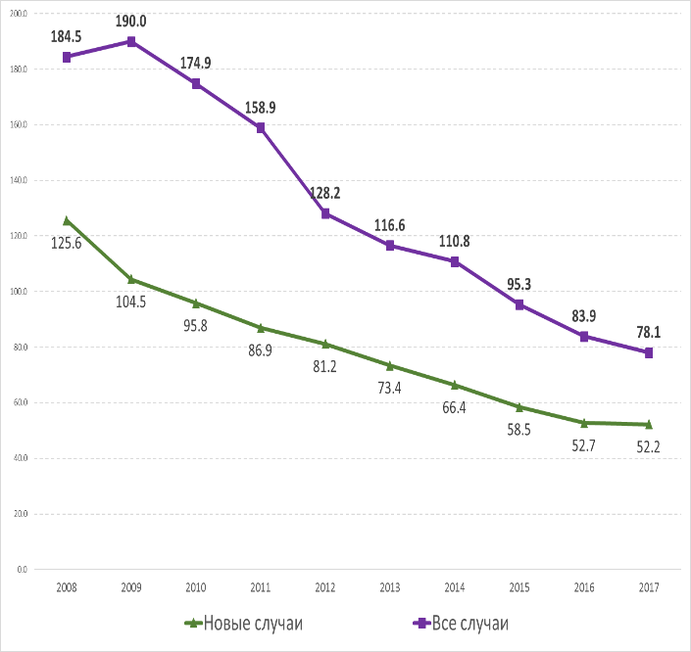  All cases  New cases | 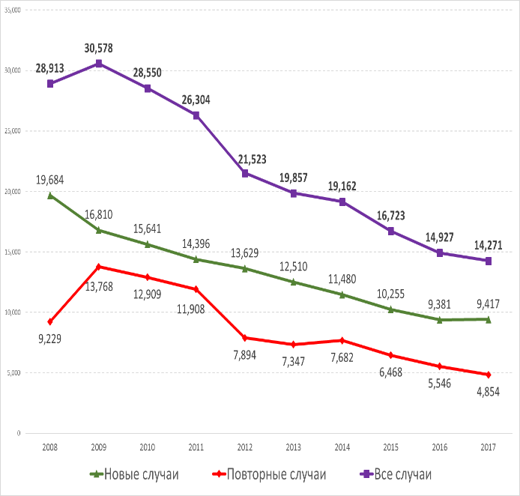  New cases  Relapses  All cases
Source: NSCP, June 2018
The TB mortality in Kazakhstan steadily and significantly decreases over time. Since the coverage and quality of the state vital registration system are adequate, this trend reflects the true reduction in TB burden in the country. The WHO-estimated mortality rate in Kazakhstan for 2017 was one of the lowest among the Former Soviet Union countries, and during the past 10 years it decreased by more than 17 times (from 19 to 1.1 per 100,000 population, including mortality from HIV-associated TB). The data from the state vital registration system confirms these estimates: for the period from 2008 to 2017, the TB mortality rate decreased from 16.6 to 3.0 cases per 100,000 (Figure 3).

Figure 3 WHO-estimated TB (including TB/HIV) mortality rate compared to the data from the state vital registration system of the Republic of Kazakhstan, per 100,000, 2008-2017
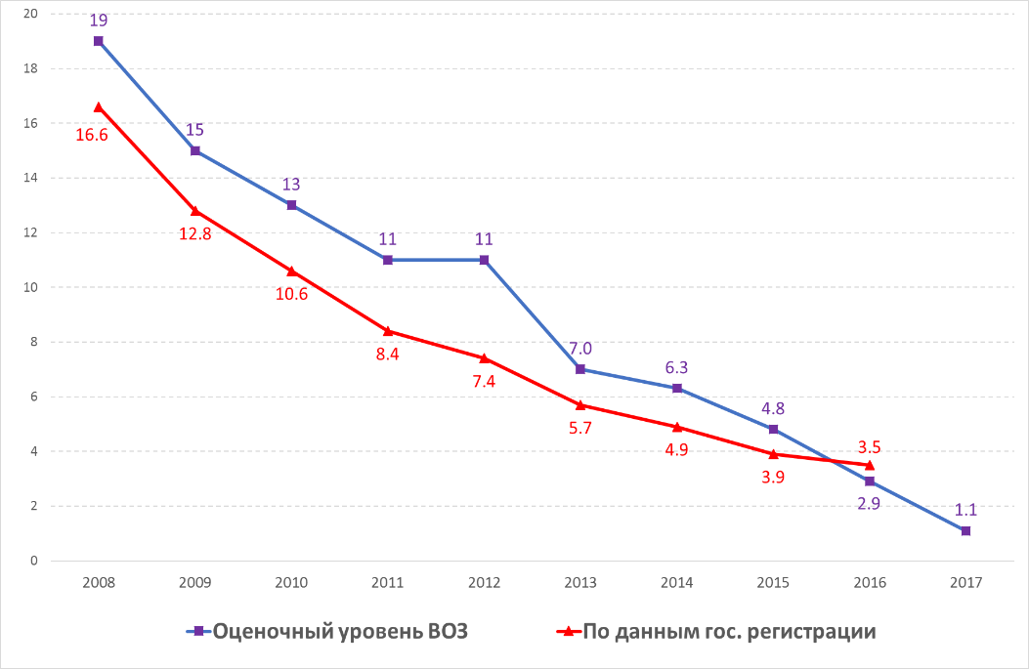
According to state registration data
WHO-estimated level
As in other former USSR countries, the high burden of drug resistance is the key challenge for the National TB Program and a serious obstacle for efficient TB control in Kazakhstan.
Kazakhstan is among 27 countries with a high MDR-TB incidence and is a high-priority country in collaboration with the WHO.

According to the NSCP data for the year 2017, the results of drug susceptibility testing (DST) to first-line drugs (FLDs) conducted by regional reference laboratories and the National Reference Laboratory (NRL) of the NSCP revealed that the proportion of rifampicin-resistant TB (RR-TB) was 25.9% among new cases and 47,0% among previously treated cases. In most RR-TB cases, we also observe isoniazid resistance, i.e. multi-drug-resistant TB (MDR-TB), the proportion of which amounted to 17.2% and 35.1% of new and previously treated cases, respectively. MDR-TB prevalence in new and previously treated TB cases during the last nine years is shown in Figure 4.

Figure 4 Proportion of MDR-TB among new and previously treated TB cases with the results of DST to FLDs in Kazakhstan, %, 2008-2017

Relapses
New cases

Source: NSCP, June 2018.
5,893 MDR-TB patients were registered in Kazakhstan in 2017. Since the country reached the standard coverage (85% and more) of MDR-TB patients with adequate second-line TB drugs (SLD) treatment in 2012, the number of MDR-TB patients in the country decreased by 2,531 people from 8,424 to 5,893.

Figure 5 Number of registered MDR-TB patients in Kazakhstan between 2008 and 2017

XDR-TB
MDR-TB
HIV-associated tuberculosis is an important challenge. Kazakhstan is at concentrated stage of HIV epidemics. According to UNAIDS estimates, 27,000 people lived with HIV (PLHIV) in the country in 2017 , including 3,700 new infections. The estimated HIV prevalence rate in adult (15-49 years) general population was 0.2%.
According to the Republican AIDS Center, as of end-2017, a total of 32,573 HIV-positive cases were registered in the country since the onset of the epidemic (of which 29,980 Kazakhstan citizens) and 9,448 individuals died; the number of people living with HIV – 20,841 (77.2% of UNAIDS-estimated number). During 2017, 3,023 new cases of HIV infections were registered (81.7% of UNAIDS estimates), including 2,856 Kazakhstan citizens (16.2 per 100,000).
The main transmission route is heterosexual contact (62.0% cases), followed by parenteral route when using drugs (29.2%). In key affected populations, HIV prevalence is estimated at 8.5% among people using injectable drugs, at 3.2% among men having sex with men, at 2.7% among prisoners and at 1.9% - among sex workers.
In 2017, almost all (98%) TB patients on treatment were tested for HIV, and 87% of PLHIV registered at AIDS Centers were screened for TB by any method. The number of notified cases (all forms) with HIV-associated TB was 734 in 2017, compared to 736 in 2016 and 781 in 2015. TB/HIV prevalence among all TB cases was 5.0% in 2017 (2015 – 4.7%, 2016 – 4.9%). In 2017, 661 patients with TB/HIV co-infection were enrolled in ART, which accounted to 90.1% ART coverage among TB/HIV patients, compared to 87.2% in 2016 (642 patients enrolled out of 736) and 65.3% (510 / 781) in 2015.
The proportion of HIV-infected persons among TB patients in the penitentiary system is high and increasing with time. In detention facilities, TB/HIV prevalence was about 9% in 2011-2013, but it increased significantly during the following years and was 12.0% in 2014, 17.8% in 2015 and 26.6% in 2016. Tuberculosis is still an important problem in the penitentiary sector. The successful implementation of the criminal law reform, including application of alternative sanctions, has allowed reducing the number of imprisoned population. While in 1998, Kazakhstan had the third-highest rate of prison population per 100,000 in the world; in 2017 it was ranked the 82nd. The average annual number of inmates in the penitentiary system (PS) of Kazakhstan amounted to 35,000 people in 2017.
During the last decade, the TB incidence in the penitentiary system (PS) decreased significantly. The annual number of notified TB cases in the detention institutions (DI) and pre-trial detention units (PU) between 2008 and 2016 decreased 5.3 times and 3.3 times, respectively, and 4.2 times in the system as a whole (Figure 6). At the same time, the dynamic indicator of all TB cases notification per 100,000 in the penitentiary system decreased from 5,600 to 1,600, or 3.8 times. The incidence rate (new cases and relapses) in the penitentiary system is almost 30 times higher than the corresponding figure for the country as a whole.
Figure 6 Number of all TB notified cases in the penitentiary system of Kazakhstan, 2008-2016
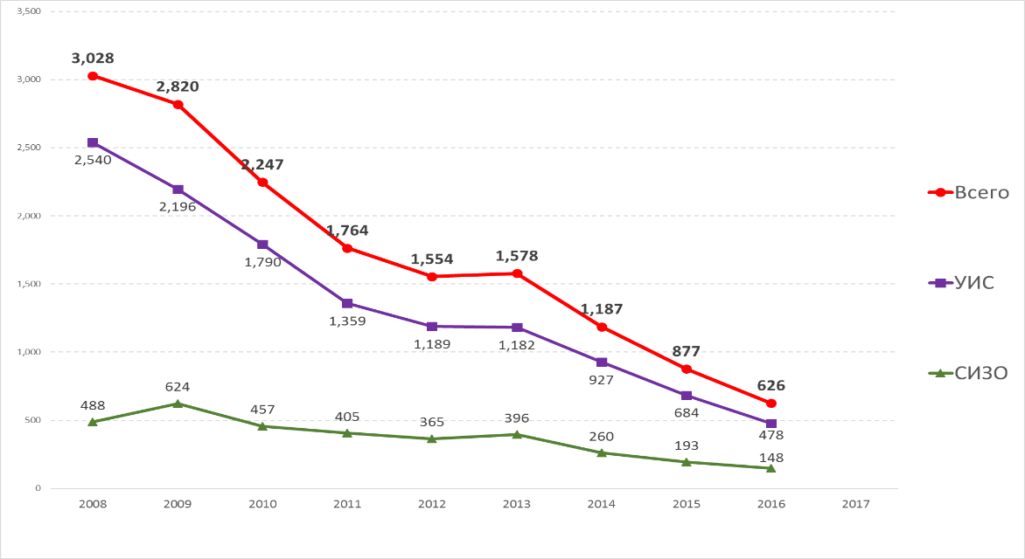
DI
PU
Total

The country has achieved one of the world's highest rates of TB and MDR-TB treatment efficacy. In 2017, the success rate of treatment of newly diagnosed patients with susceptible tuberculosis was 87.0% (2014 - 86.4%, 2015 - 87.6%, 2016 - 86.6%). At the same time, the success rate of treatment of MDR-TB patients registered in 2014 was 78.2% (in 2011 - 69.4%, 2012– 75.1%, 2013 - 74.5%).

INTERNAL ENVIRONMENT

MANAGEMENT
The Ministry of Health of the Republic of Kazakhstan is an executive body of state authority managed by the Government of the Republic of Kazakhstan, which performs the functions of state policy development, statutory regulation and control in the field of health care. The Ministry of Health of the Republic of Kazakhstan performs coordination and monitoring of activities of subordinate health care organizations, and carries out its activities in compliance with the Constitution of the Republic of Kazakhstan, constitutional laws, acts of the President and the Government of the Republic of Kazakhstan and other regulatory legal acts. The Ministry of Health of the Republic of Kazakhstan carries out its activities in cooperation with other state authorities, local government bodies and other institutions regardless of their organizational and legal form, as well as with international financial and relevant organizations. The Ministry of Health of the Republic of Kazakhstan is fully responsible for the provision of medical services to the country population.
The Government of the Republic of Kazakhstan considers TB as one of the priority areas of public health, which is reflected in legislative acts, the main ones are the following:

Code of the Republic of Kazakhstan No. 193-IV dated September 18, 2009 “On Population Health and Healthcare System”

Densaulyk State Health Care Development Program of the Republic of Kazakhstan for the years 2016-2019
- Comprehensive Plan for TB control in the Republic of Kazakhstan for the years 2014 - 2020
- Order of the Ministry of Health of the Republic of Kazakhstan No. 994 dated 12.22.2017 “On Approval of the Instructions for Tuberculosis Care Organization”
The state-guaranteed provision of TB care to TB patients is carried out based on the principles of legality, respect for human and civil rights, and general accessibility according to the scope provided by the State Program of Guaranteed Free Medical Care to RK Citizens.
The basis of the National TB Program of the Republic of Kazakhstan is the Resolution of the Government of the Republic of Kazakhstan No. 597 dated May 31, 2014 “On Approval of the Comprehensive Plan for TB control in the Republic of Kazakhstan for 2014-2020” and TB regulatory legal acts.
The Comprehensive Plan developed pursuant to the instructions of the President of the Republic of Kazakhstan addressed in the “Strategy 2050 for Kazakhstan: new political course of the established state” and “Nurly Zhol - the way to the future” is fully synchronized with the World Health Organization’s EndTB Global Strategy for the years 2016-2035.
The NSCP goal is to reduce TB burden by providing common access to diagnostic and treatment services for all tuberculosis forms.
In accordance with the Global Strategy to End TB by 2035, the NSCP has defined the following goals to be achieved by 2020:
- TB mortality rate: 3.2 per 100,000
- TB incidence rate: 52.0 per 100,000
- MDR-TB treatment success rate: 75%
- MDR-TB case notification rate: more than 90%
The Comprehensive Plan provides the following activities: reorganization of anti-TB institutions, phased optimization and reprofiling of the bed capacity of anti-TB institutions involving the improvement of the financing mechanism, introduction of new methods for early TB diagnosis and treatment, improvement of the model of providing medical care to TB patients, including people from key and hard-to-reach populations, involving the phased introduction of patient-centered outpatient treatment of TB patients, medical staff training and improvement of infection control measures. The coverage of outpatient TB patients with social assistance is increasing from year to year.
In 2002, pursuant to the Decree of the Government of the Republic of Kazakhstan No. 1037 dated September 20, 2002, the Country Coordinating Mechanism (CCM) was established with the aim to coordinate the Global Fund grant at the Government level, and to make joint decisions. In accordance with the Global Fund’s guidelines, the CCM consists of 26 members, including representatives of 5 ministries (Ministry of Health, Ministry of Internal Affairs, Ministry of Defence, Ministry of Justice, Ministry of Education and Science), international organizations, NGOs and people suffering from diseases. NGO representatives in the CCM make up 40% of the total composition and are represented by national NGOs; organizations of communities of people living with TB and HIV; key affected populations; confessional organizations; international non-governmental private and academic organizations that are not multilateral or bilateral organizations. For the purpose of effective decision making, the CCM may include not more than one member from each electoral group, who has a conflict of interest (except for persons who are CCM members due to their positions and who have no any voting rights). The concept of a conflict of interest applies at least to grant recipients, in particular, to representatives of principal recipients (PR) and sub-recipients (SR) or sub-sub-recipients.

FINANCIAL TB CONTROL RESOURCES
In Kazakhstan, TB control activities are financed from the state/republican budget, regional/local budgets, the Compulsory Medical Insurance Fund and departmental budgets. The Comprehensive Plan for TB control in the Republic of Kazakhstan for 2014-2020 provides detailed estimates of the overall needs of the TB control program, public funding, contributions from external donors and the funding shortage in implementing the priority of TB control activities. The financial estimates for the national TB control program are based on a thorough analysis of epidemiological trends, a planned increase in the coverage with activities, improved access to modern diagnostic technologies and service delivery capabilities.
The total estimated amount of public expenditures for TB control activities for a period of 4 years (2019-2022) is KZT 201.94 billion or the equivalent of USD 590.32 million (at USD/KZT exchange rate of KZT 342).
The share of expected domestic financing in the total volume of financial assignments for the National TB Program is presented in Table 1.

TABLE 1. FINANCIAL ASSIGNMENTS FOR THE NATIONAL TB PROGRAM IN 2019-2022 (USD)
 | 2019 | 2020 | 2021 | 2022
Total funding requirements for the National TB Program | 149,353,198 | 154,238,861 | 154,238,861 | 154,238,861
Total expected resources | 155,087,425 | 153,426,627 | 151,929,715 | 151,226,166
Total expected domestic resources | 147,208,937 | 147,490,034 | 147,709,281 | 147,928,528
Total external funding | 7,878,488 | 5,936,592 | 4,220,433 | 3,297,637
Total expected funding from donors, excluding GF | 1,946,320 | 1,800,000 | 1,800,000 | 1,800,000
Total expected funding from the Global Fund | 5,932,168 | 4,136,592 | 2,420,433 | 1,497,637
Share of domestic financing in the total volume of financial assignments for the TB control programs | 94.9% | 96.1% | 97.2% | 97.8%

Over the past two years (2017-2018), external financial support for TB control in Kazakhstan amounted to USD 14.49 million, which is 4.7% of the total TB control costs in the country for the period under review (USD 310.43 million). The main external source to fund TB control activities was the Global Fund to Fight AIDS, Tuberculosis and Malaria, as well as USAID and the Government of the Netherlands. It is assumed that total external financing in 2019-2022 will cover about 3.4% of the expected TB control program funding (USD 611.67 million), and more than 96.4% of needs (USD 590.34 out of USD 611.67 million) will be satisfied through the domestic funding (Figure 7).
Figure 7 TB funding trends in Kazakhstan for 2019-2022
Total expected domestic resources (US)
Total expected funding from the Global Fund (USD)
Total expected funding from donors, excluding GF
Share of domestic financing in the total volume of financial assignments

The total funding shortage for 2020-2022 is estimated at the level of USD 6.13 million, which is 1.3% of the total needs deficit in the amount of USD 462.72 million for the same period.
The most important shortcomings facing the National TB Program are associated with the provision of (1) consumables and reagents for the rapid TB diagnosis in the penitentiary sector, (2) new and repurposed M/XDR-TB drugs in the penitentiary sector and (3) support for the involvement of NGOs and patient organizations in conducting TB control activities among highly vulnerable and hard-to-reach populations.
- Domestic financing for TB diagnosis consumables and reagents: the cost of consumables and reagents for microscopy, culture and solid DST is covered completely from internal sources, both for civil and penitentiary sector institutions. Procurement of reagents for rapid investigations (Xpert, automated MGIT and LPA Hain) is covered partially from the GF grant funds for the civil and penitentiary sectors, and from public funds for the MoH institutions. Given the high price for 1 Xpert cartridge for procurement from the state budget (USD 71 in 2017 and USD 54 in 2018), for 2019 the full demand of the MOH institutions will be covered through procurement from GDF at preferential prices. At the same time, the penitentiary system’s demand for Xpert cartridges will be covered from the GF grant in 2019. During the transition period, the country intends to develop a mechanism to purchase Xpert cartridges for the penitentiary system as part of a joint order with the MOH directly from international organizations (GDF). It is proposed to use the mechanism for procurement through the GDF until a competitive environment is created in the country by delegating the manufacturer’s right to sell cartridges and maintain Xpert equipment to several representatives in Kazakhstan.
The MIA will cover purchases of rapid test (automated MGIT and LPA Hain) reagents for the penitentiary system from its own funds: 100% of needs since 2022.

- M/XDR-TB treatment drugs: procurement of M/XDR-TB drugs is carried from the public funds and the GF grant for MOH and MIA institutions. However, in connection with recent WHO recommendations for 2018, the need for procurement of new (Bedaquiline and Delamanid) and repurposed (Clofazimine) drugs in subsequent years will increase to 2500-3000 patients per year. The expected average cost of a full treatment course using new and repurposed drugs will be about USD 4,000 for MDR-TB patients and USD 6,200 for pre-XDR and XDR-TB patients. For 2019, the demand for M/XDR-TB drugs, including new and repurposed drugs, will be covered for the civilian sector from the state budget (2,000 patients), including direct procurement from the GDF at preferential prices and partly through the GF grant (417 patients), and for the penitentiary sector - entirely through the GF grant (78 patients). During the transition period, the country intends to approve a mechanism to purchase new and repurposed drugs for the penitentiary system as part of a joint order with the MOH directly from international organizations (GDF). Procurement of drugs through the GDF will be carried out until completion of the registration procedure for new and repurposed drugs in accordance with the national law.
The Ministry of Internal Affairs will gradually cover the procurement of M/XDR-TB drugs for the penitentiary system at the cost through own funds: for MDR-TB patients - 100% of the needs from 2021 and for pre-XDR and XDR-TB patients - 50% of the needs in 2021 and 100% of the needs from 2022.

- Support of NGOs and patient organizations involvement to conduct TB control activities among highly vulnerable and hard-to-reach populations: there is a significant progress in engaging non-governmental organizations in the TB epidemic response measures. The main NGOs’ activities are aimed at assisting medical institutions in early detection and ensuring patient adherence to TB treatment. The main risk groups, among which NGOs work to ensure early detection and patient adherence to TB treatment, are people who inject drugs (PWID), homeless people, external and internal migrants, alcohol abusers, inmates and former inmates. At the same time, the involvement of NGOs in TB control activities is funded from donor sources, mainly the GF. Thus, today, grants have been allocated to 10 NGOs that work in 8 regions to provide services for early TB detection and increase TB patient adherence at the outpatient treatment stage.
In Kazakhstan, the opportunities for social contracting to NGOs to provide services, including TB control services, are defined in regulatory acts. At the same time, the number of organizations involved in TB control activities from national sources is limited, technical enquiries are far from perfect, and social contracting procedures take from 3 to 6 months, therefore, afterwards there is not enough time to implement a social contract, thus it’s very difficult to implement it efficiently.
In this regard, during the transition period the following should be done: to ensure improvement of regulatory legal acts on social contracting to NGOs; to calculate the cost of services provided by NGOs as part of project activities and to use these calculations for budget planning; to develop uniform standards for NGO staff training in all areas that are necessary for their activities; to increase gradually the number of NGOs that can be socially contracted from national sources, subject to a gradual decrease of donor funding.
As for the HIV component, the achievements of the Global Fund Grant aimed to improve the mechanisms to provide state social contracting to NGOs will be used in the development of laws and regulations for the implementation of NGOs’ TB control activities.

HUMAN RESOURCES
Universal access to high-quality TB treatment services cannot be provided without having “the right people at the right place at the right time, who have the right skills and motivation”. The effectiveness of the National TB Program depends on the availability of highly motivated and qualified staff who will have regular access to empirically supported resources to continuously update their skills and knowledge required for the provision of services of proper quality.
Sufficient human resources: as recognized by many experts and formulated in the Comprehensive Plan for TB control in the Republic of Kazakhstan for 2014-2020, one of priorities is to develop HR policy. The HR policy should determine types of healthcare workers, their quantity and locations where they are required in order to achieve the TB control goals of the country. The Comprehensive Plan for TB Control stresses the importance of properly trained and highly motivated healthcare workers to render TB control services.
More than 23% of TB professionals are close to the retirement age while the inflow of young TB specialists is minimal. Currently, remuneration mechanisms do not encourage high labor productivity. Establishing of performance indicators and additional payments for predetermined target achievement can improve the motivation of medical personnel. However, this requires the introduction of changes in legislation in order to ensure performance-based remuneration.
Financial factors are not the only reason for low interest in this discipline among of graduates. Perhaps, TB area is not attractive for them because of the high level of stigma, health risks and a very narrow range of practices. If proper response measures would not be taken, these facts may cause a critical shortage of personnel. Potential solutions of this problem can be the following: professional integration of phthisiology into broader medical disciplines (for example, pulmonology, infectious diseases, family medicine) and strengthening the monitoring of healthcare workers for timely detection and treatment of latent tuberculosis and prevention of nosocomial TB transmission within medical institutions.

Institutionalization of donor-supported trainings: continuing medical education of phthisiologists and family doctors is provided on a mandatory basis every 3 years at the phthisiology department of medical academies and universities. Specialists having secondary specialized medical education and providing TB control services (nurses) must improve their professional skills in medical schools and primary health care institutions every five years. In addition to medical universities, continuing medical education is provided in the form of short-term training courses, seminars, on-the-job training, etc. under the sponsorship of various donor organizations. Short-term training programs have been integrated into the mandatory structure of continuing medical education, which is currently supported by the government, but some new trainings (M/XDR-TB, pharmacovigilance, NGO involvement) should be included therein.
NGO staff support policy: in accordance with the ultimate TB strategy, a modern concept of a people-centered TB treatment model involves the activation of resources of NGOs and communities for TB prevention, detection, treatment and monitoring. Gradual transition from a predominantly inpatient to an outpatient model requires a revision of human resource requirements, both at the hospital level and on outpatient basis. The experience of involving NGOs in TB control activities implemented under the current GF grant is used as a good example for potential involvement of NGO workers in early TB diagnosis among vulnerable groups, supporting adherence to TB treatment, as well as conducting ACSM activities, preventing stigma and discrimination. For the purpose of further expanding of the activities at the community level with the help of community members, it is necessary to define a specific NGOs’ role and develop a governing policy and personnel capacity building in organizations.

HEALTH MANAGEMENT INFORMATION SYSTEMS IN TB FIELD
Since 2013, NTP has been using an individualized electronic TB information system in real time. A detailed analysis of the TB epidemiological data as well as the national system of TB registration, monitoring and evaluation is reflected in the assessment conducted by the WHO Regional Office for Europe in 2017. The Report highlights the system strengths such as the availability of a well-functioning real-time electronic database and effective mechanisms for ensuring data quality at all levels; a universal coverage and high quality of the country vital registration system, reliable connection of this system with the information system of the National TB Program, etc.
At the same time, it should be noted that this assessment has revealed a number of gaps to be addressed. The most significant shortcomings include the gaps in the content of the TB registration, reporting and data processing system at the national level. For example, WHO-recommended definitions and classifications (2013) for registration of TB cases and treatment outcomes have not been fully implemented, which makes it difficult to submit reports to the WHO as well as proper monitoring and evaluation of the epidemiological situation for making decisions within the National TB Program. Not all diagnosed active TB cases are included in the final annual country report. As a result, there are data discrepancies and inconsistencies, including data provided by the country to the WHO.
There are difficulties in accounting and analysis of laboratory diagnostics and confirmation of cases due to incomplete inclusion of the data of all used methods (including various DST methods) and data exchange between regional and central level facilities. In addition, there is also incomplete compliance and limited accuracy of data on epidemiological surveillance of pediatric tuberculosis.
In view of the aforesaid, the electronic TB information system is being updated under the current GF grant, including correction of identified gaps. At the same time, both external and internal resources should be provided during the transitional period in order to update database modules in view of the recent WHO recommendations on TB diagnosis, treatment, pharmacovigilance, monitoring and evaluation, as well as to ensure the maintenance of the system at various levels of data entry.

TRANSITION PLANNING

The assessment of the country’s readiness for transition reveals a minimal risk of transition from external to domestic financing for national TB control activities.
Strong regulatory framework as well as health and TB control strategies approved by the government, substantial political will, a high level of TB services implementation in the PHC network, and a well-developed institutional framework for TB program management and coordination including clear reporting - all these facts create a favorable environment for sustainable transition.
During the transition period, the following areas require particular attention: (a) the need to ensure continuous access to high-quality laboratory diagnosis and treatment of the M/XDR TB until the government takes a full control, especially in the penitentiary sector; (b) the need to strengthen mechanisms and expand the involvement of NGOs in TB control activities throughout the country; (c) the need to continuously build the capacity of health care workers and NGOs to perform efficient TB control activities.

SUSTAINABILITY AND PREPAREDNESS PLAN FOR TRANSITION from international to domestic financing for TB control activities.
Goal: ensuring a sustainable transition to full funding from domestic sources for effective implementation of TB control activities in the Republic of Kazakhstan for 2019-2022.
Objective 1: Ensuring the sustainability of universal access to high-quality preventive, diagnostic and treatment services for TB patients and application of patient-centered strategic measures.
Activity 1.1: Development and approval of a mechanism to ensure the procurement of rapid TB diagnostics tests for the penitentiary system using international mechanisms at preferential prices.
Activity 1.2: Ensuring the uninterrupted supply of tests and accessories for the rapid TB diagnosis in the penitentiary system.
Activity 1.3: Ensuring the maintenance of laboratory equipment and ventilation systems in bacteriological reference laboratories as well as in high biological risk areas.
Activity 1.4: Training and attestation of local engineers for the purpose of maintenance and repair of laboratory equipment in bacteriological laboratories: biosafety cabinets and ventilation systems.
Activity 1.5: Development and approval of a mechanism to ensure the procurement of new and repurposed TB drugs for the penitentiary system using international mechanisms at preferential prices.
Activity 1.6: Ensuring registration of new WHO-recommended drugs for treatment of M/XDR-TB patients.
Activity 1.7: Ensuring the uninterrupted supply of TB drugs for treatment of M/XDR-TB patients in the penitentiary system.
Activity 1.8: Training of PHC specialists in TB and DR-TB management, including penitentiary system staff.
Activity 1.9: Expanding the implementation of measures for active monitoring of safe use of TB drugs, including: coordination of activities, updating of the drug module of the National TB Register (NTBR), staff training in pharmacovigilance and aDSM as well as in the use of the drug module.
Objective 2: Increase the human resource capacity to ensure efficient TB control
Activity 2.1: Technical assistance in revising the payment mechanisms of providers that render TB care to the population to improve the system efficiency.
Activity 2.2: Technical assistance in the development and implementation of incentive mechanisms for TB service workers (physicians, nurses, laboratory staff).
Activity 2.3: Training of regional TB dispensary and PHC network managers focused on managerial and practical aspects to support the introduction of new payment mechanisms in TB control institutions.
Activity 2.4: Training of regional TB dispensary and PHC network managers in the implementation of the outpatient TB patient care model and optimization of the bed capacity.
Activity 2.5: Establishment of the Center for Clinical Mentoring and Advanced Training at the NSPC using remote technologies to provide high-quality care and treatment services for TB and DR-TB patients.
Activity 2.6: Regularly review and update of training programs at all levels of medical education for physicians and nurses with the aim to ensure compliance with recent WHO recommendations.
Activity 2.7: Periodic update of the national human resources plan to support the production, recruitment, appointment and retention of human resources for TB control.
Activity 2.8: Introduction of incentive mechanisms for TB service workers to ensure staff retention and involve young doctors in TB control programs.
Objective 3: Strengthening the NTP monitoring and evaluation capacity.
Activity 3.1: Support for NTBR improvement activities in compliance with recent WHO recommendations.
Activity 3.2: Maintenance of the national electronic TB information system.
Activity 3.3: Revision and updating of methodological recommendations for records and reporting forms used in conducting TB control activities in accordance with international standards.
Activity 3.4: Support to monitoring visits by the central NTP unit to carry out ongoing monitoring and evaluation during the transition phase.
Activity 3.5: Provision of regular update of the operational research plan to resolve emerging issues and support their implementation.
Objective 4: Involvement of civil society organizations, non-governmental organizations and communities in TB control activities.
Activity 4.1: Technical assistance to NGOs in calculating the cost of services involved in TB control activities.
Activity 4.2: Training of community and organizations representatives in program management, strategic planning and development of organizations and implementation of TB control activities.
Activity 4.3: Training of community and organization representatives in conducting activities to control drug-susceptible and drug-resistant tuberculosis.
Activity 4.4: Expanding the implementation of the NGO and community grants program based on innovative patient-centered approaches, ensuring adherence to TB treatment and control among at-risk groups.
Activity 4.5: Strengthening the monitoring and evaluation of grants to NGOs and communities based on innovative patient-centered approaches and TB control activities among at-risk groups.

Appendices 1a and 1b contain the transition plan’s activities, entities responsible for implementation, deadlines and estimated financial needs.
Appendix 2 indicates the level of coverage of the planned activities for transition to internal sources during the implementation period.

Appendix No. 1а
No | Activity | Completion form | Entity responsible for implementation | Terms of execution
Objective 1: Ensuring the sustainability of universal access to high-quality preventive, diagnostic and treatment services for TB patients and application of patient-centered strategic measures
1.1 | Development and approval of a mechanism to ensure the procurement of rapid TB diagnosis tests for the penitentiary system using international mechanisms at preferential prices | Mechanism approved | MIA RK, Regional Health Departments MoH RK | 2019-2022
1.2 | Ensuring the uninterrupted supply of tests and accessories for the rapid TB diagnosis in the penitentiary system | Budget assured | MIA RK | 2019-2022
1.3 | Ensuring the maintenance of laboratory equipment and ventilation systems in bacteriological reference laboratories as well as in high biological risk areas | Maintenance Plan approved | MIA RK, Regional Health Departments MoH RK | 2019-2022
1.4 | Training and attestation of local engineers for the purpose of maintenance and repair of laboratory equipment in bacteriological laboratories: biosafety cabinets and ventilation systems | Training Plan approved | MIA RK, Regional Health Departments MoH RK | 2019-2022
1.5 | Development and approval of a mechanism to ensure the procurement of new and repurposed TB drugs for the penitentiary system using international mechanisms at preferential prices | Mechanism approved | MIA RK | 2019-2022
1.6 | Ensuring the uninterrupted supply of TB drugs for treatment of M/XDR-TB patients in the penitentiary system | Budget assured | MIA RK | 2019-2022
1.7 | Training of PHC specialists in TB and DR-TB management, including penitentiary system staff | Training Plan approved | MIA RK, Regional Health Departments MoH RK, NSCP | 2019-2022
1.8 | Expanding the implementation of measures for active monitoring of safe use of TB drugs, including: coordination of activities, updating of the drug module of the National TB Register (NTBR), staff training in pharmacovigilance and aDSM as well as in the use of the drug module | Activities implemented | Regional Health Departments MoH RK, NSCP, National Centre for Expertise of Drugs, Medical Products and Medical Equipment | 2019-2022
Objective 2: Increase the human resource capacity to ensure effective TB control
2.1 | Technical assistance in revising the payment mechanisms of providers that render TB care to the population to improve the system efficiency | TA realized, report presented | MOH RK, Regional Health Departments MoH RK, NSCP | 2019-2022
2.2 | Technical assistance in the development and implementation of incentive mechanisms for TB service workers (physicians, nurses, laboratory staff) | TA realized, report presented | MOH RK, Regional Health Departments MoH RK, NSCP | 2019-2022
2.3 | Training of regional TB dispensary and PHC network managers focused on managerial and practical aspects to support the introduction of new payment mechanisms in TB control institutions | Training Plan approved | MOH RK, Regional Health Departments MoH RK, NSCP | 2019-2022
2.4 | Training of regional TB dispensary and PHC network managers in the implementation of the outpatient TB patient care model and optimization of the bed capacity | Training Plan approved | MOH RK, Regional Health Departments MoH RK, NSCP | 2019-2022
2.5 | Establishment of the Center for Clinical Mentoring and Advanced Training at the NSPC using remote technologies to provide high-quality care and treatment services for TB and DR-TB patients | Training Plan and Program developed and approved | NSCP | 2019-2022
2.6 | Regularly review and update of training programs at all levels of medical education for physicians and nurses with the aim to ensure compliance with recent WHO recommendations | Update of training programs | NSCP, Republican Center for Health Development | 2019-2022
2.7 | Periodic update of the national human resources plan to support the production, recruitment, appointment and retention of human resources for TB control | Plan revised and approved | MOH RK, MIA RK, Regional Health Departments MoH RK, NSCP | 2019-2022
2.8 | Introduction of incentive mechanisms for TB service workers to ensure staff retention and involve young doctors in TB control programs | Mechanisms developed and approved | MOH RK, MIA RK, Regional Health Departments MoH RK | 2019-2022
Objective 3: Strengthening the NTP monitoring and evaluation capacity
3.1 | Support for NTBR improvement activities in compliance with recent WHO recommendations | Contract with IT Company signed | MOH RK, NSCP | 2019-2022
3.2 | Maintenance of the national electronic TB information system | Contract for maintenance signed | MOH RK, NSCP | 2019-2022
3.3 | Revision and updating of methodological recommendations for records and reporting forms used in conducting TB control activities in accordance with international standards | Methodological recommendations approved | MOH RK, Republican Center for Health Development, NSCP | 2019-2022
3.4 | Support to monitoring visits by the central NTP unit to carry out ongoing monitoring and evaluation during the transition phase | Monitoring and Evaluation Plan approved and visits supported | MOH RK, MIA RK, Regional Health Departments MoH RK, NSCP | 2019-2022
3.5 | Provision of regular update of the operational research plan to resolve emerging issues and support their implementation | Plan revised and approved | MOH RK, MIA RK, Regional Health Departments MoH RK, NSCP | 2019-2022
Objective 4: Involvement of civil society organizations, non-governmental organizations and communities in TB control activities
4.1 | Technical assistance to NGOs in calculating the cost of services involved in TB control activities | TA realized, report presented | MOH RK, MIA RK, Regional Health Departments MoH RK, NSCP | 2019-2022
4.2 | Training of community and organization representatives in program management, strategic planning and development of organizations and implementation of TB control activities | Training Plan and Program approved | MOH RK, Regional Health Departments MoH RK, NSCP | 2019-2022
4.3 | Training of community and organization representatives in conducting activities to control drug-susceptible and drug-resistant tuberculosis | Training Plan and Program approved | MOH RK, MIA RK, Regional Health Departments MoH RK, NSCP | 2019-2022
4.4 | Expanding the implementation of the NGO and community grants program based on innovative patient-centered approaches, ensuring adherence to TB treatment and control among at-risk groups | NGOs contracted, activities realized | MOH RK, MIA RK, Regional Health Departments MoH RK, NSCP | 2019-2022
4.5 | Strengthening the monitoring and evaluation of grants to NGOs and communities based on innovative patient-centered approaches and TB control activities among at-risk groups | M&E Plan of the NGOs developed and approved, visits realized | MOH RK, MIA RK, Regional Health Departments MoH RK, NSCP | 2019-2022

Appendix No. 1b
Activity | 2019 |  |  | 2020 |  |  | 2021 |  |  | 2022
 | Republican budget | Donors | Deficit | Republican budget | Donors | Deficit | Republican budget | Donors | Deficit | Republican budget | Donors | Deficit
Objective 1
1.2 Ensuring the uninterrupted supply of tests and accessories for the rapid TB diagnosis in the penitentiary system |  | 15,764,000 |  |  | 54,060,650 |  |  | 50,941,800 |  | 26,121,550 | 26,121,550
1.3 Ensuring the maintenance of laboratory equipment and ventilation systems in bacteriological reference laboratories as well as in high biological risk areas | 50,947,618 | 60,532,850 | 20,000,000 | 56,042,380 |  | 20,000,000 | 61,646,618 |  | 20,000,000 | 67,811,280 |  | 20,000,000
1.4 Training and attestation of local engineers for the purpose of maintenance and repair of laboratory equipment in bacteriological laboratories: biosafety cabinets and ventilation systems |  |  | 8,000,000 |  | 7,861,000 |  |  | 7,861,000
1.7 Ensuring the uninterrupted supply of TB drugs for treatment of M/XDR-TB patients in the penitentiary system |  | 98,749,700 |  |  | 443,388,400 |  |  | 122,402,000
1.8 Training of PHC specialists in TB and DR-TB management, including penitentiary system staff | 48,362,125 | 13,247,850 |  | 48,362,125 | 8,148,000 |  | 48,362,125 | 8,148,000 |  | 48,362,125 | 8,148,000
1.9 Expanding the implementation of measures for active monitoring of safe use of TB drugs, including: coordination of activities, updating of the drug module of the National TB Register (NTBR), staff training in pharmacovigilance and aDSM as well as in the use of the drug module | 133,052,558 | 45,763,200 |  | 133,052,558 | 18,582,200 |  | 133,052,558 | 11,173,400 |  | 133,052,558 | 0
Objective 2
2.1 Technical assistance in revising the payment mechanisms of providers that render TB care to the population to improve the system efficiency |  | 4,200,000
2.2 Technical assistance in the development and implementation of incentive mechanisms for TB service workers (physicians, nurses, laboratory staff) |  | 4,200,000
2.3 Training of regional TB dispensary and PHC network managers focused on managerial and practical aspects to support the introduction of new payment mechanisms in TB control institutions |  |  |  |  | 12,386,500 |  |  | 8,148,000
2.4 Training of regional TB dispensary and PHC network managers in the implementation of the outpatient TB patient care model and optimization of the bed capacity |  | 6,619,900 |  |  |  |  |  | 8,148,000 |  |  | 8,148,000
2.5 Establishment of the Center for Clinical Mentoring and Advanced Training at the NSPC using remote technologies to provide high-quality care and treatment services for TB and DR-TB patients |  | 12,346,600 |  |  | 31,158,400 |  |  | 32,908,400 |  |  | 32,908,400
Objective 3
3.1 Support for NTBR improvement activities in compliance with recent WHO recommendations |  | 9,765,000 |  |  | 6,302,800 |  |  | 4,552,800
3.2 Maintenance of the national electronic TB information system | 27,849,335 | 10,207,050 |  | 30,634,269 |  |  | 33,697,695 |  |  | 37,067,465
3.4 Support for monitoring visits by the central NTP unit to carry out ongoing monitoring and evaluation during the transition phase | 3,051,430 | 31,204,250 |  | 3,356,573 | 24,595,200 |  | 3,692,231 | 24,595,200 |  | 4,061,454
Objective 4
4.1 Technical assistance to NGOs in calculating the cost of services involved in TB control activities |  |  |  |  | 4,196,500
4.2 Training of community and organization representatives in program management, strategic planning and development of organizations and implementation of TB control activities |  | 9,895,900 |  |  | 5,636,050 |  |  | 5,636,050
4.3 Training of community and organization representatives in conducting activities to control drug-susceptible and drug-resistant tuberculosis |  | 5,052,950 |  |  | 6,358,100 |  |  | 3,179,050 |  |  | 3,179,050
4.4 Expanding the implementation of the NGO and community grants program based on innovative patient-centered approaches, ensuring adherence to TB treatment and control among at-risk groups |  | 240,303,700 | 70,453,600 | 79,453,600 | 371,742,000 |  | 105,680,400 | 278,806,500 |  | 176,134,000 | 185,871,000
4.5 Strengthening the monitoring and evaluation of grants to NGOs and communities based on innovative patient-centered approaches and TB control activities among at-risk groups |  | 18,213,650 |  |  | 25,200,000 |  |  | 18,900,000 |  |  | 12,600,000
Total Objectives 1-4 | 263,263,067 | 586,066,600 | 98,453,600 | 350,901,505 | 1,019,615,800 | 20,000,000 | 386,131,627 | 585,400,200 | 20,000,000 | 492,610,432 | 276,976,000 | 20,000,000

Appendix No. 2: Coverage of the planned activities for transition to domestic sources (%)

Activity | 2019 | 2020 | 2021 | 2022
1.2 Ensuring the uninterrupted supply of tests and accessories for the rapid TB diagnosis in the penitentiary system | - | - | - | 100%
1.7 Ensuring the uninterrupted supply of TB drugs for treatment of M/XDR-TB patients in the penitentiary system | - | - | 100% (MDR-TB)  50% (XDR-TB) | 100% (M/XDR-TB)
3.4 Support to monitoring visits by the central NTP unit to carry out ongoing monitoring and evaluation during the transition phase | 50% | 50% | 50% | 100%
4.4 Expanding the implementation of the NGO and community grants program based on innovative patient-centered approaches, ensuring adherence to TB treatment and control among at-risk groups | - | - | 25% | 50%
4.5 Strengthening the monitoring and evaluation of grants to NGOs and communities based on innovative patient-centered approaches and TB control activities among at-risk groups | - | - | 25% | 50%

https://www.theglobalfund.org/en/portfolio/country/?loc=KAZ&k=cee65577-bd1c-4508-9205-3972358d659f
Ministry of National Economy of the Republic of Kazakhstan, Committee on Statistics, http://stat.gov.kz.
On June 19, 2018, by the decree of the President of Kazakhstan, Shymkent was assigned the status of a city of republican significance; it was withdrawn from the South Kazakhstan region, which by the same decree was renamed as Turkestan region with its capital located in the city of Turkestan.
World Bank, http://data.worldbank.org/country/kazakhstanAtlas method, in US dollars.
WHO GlobalTuberculosisReport 2018, http://www.who.int/tb/publications/global_report/en/
UNAIDS, http://www.unaids.org/en/regionscountries/countries/kazakhstan
World Prison Brief, http://www.prisonstudies.org/world-prison-brief-data
Report of an external consultant, Ye. Gurbanova, on the provision of technical assistance to strengthen control over TB and DR-TB in the penitentiary system of the Republic of Kazakhstan, 2017
. http://www.who.int/tb/health_systems/human_resources/en/
Tuberculosis epidemiological and impact analysis in Kazakhstan, 2017, WHO Regional Office for Europe, 2018

